HISTORIC ARMS
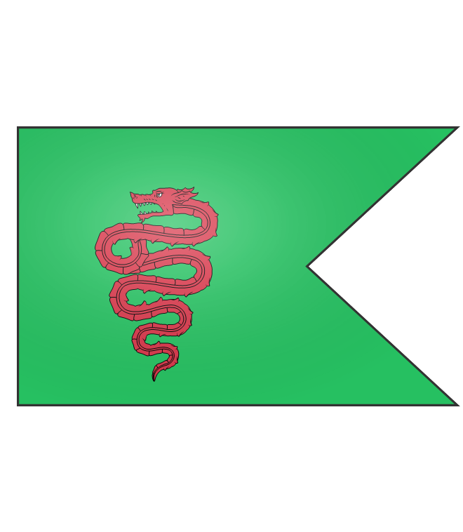 | Lazio Empire  The Dragon Banner was carried by the Legions of the Lazio Empire. Contemporary writings suggest an actual wooden dragon was carried by standard bearers.
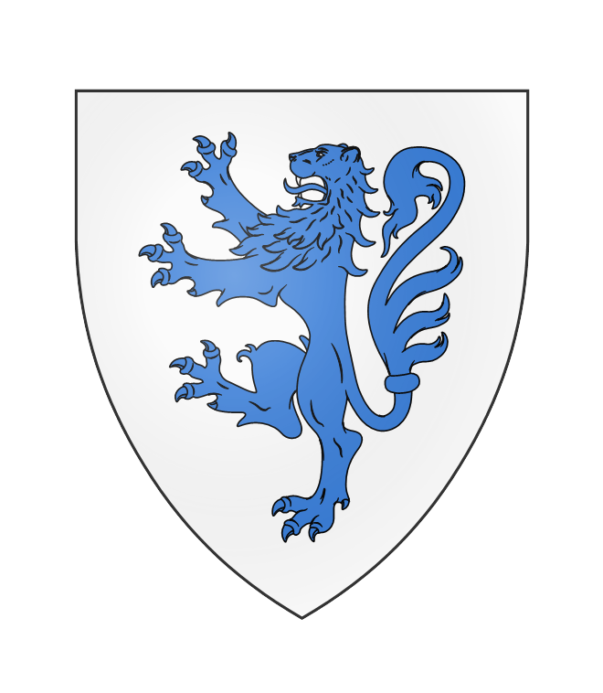 | Saesia  The personal arms of Aedward the Great, also known as Aedward the Lion.
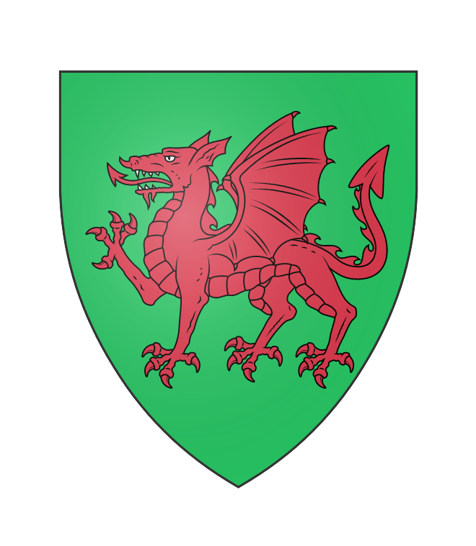 | Brydain  The traditional arms of Brydain pay homage to the Dragon Banner of the Lazio Empire.
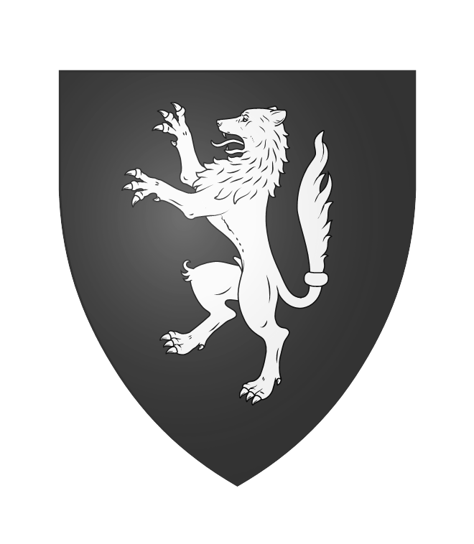 | Dansklaw  The grey wolf is a symbol of the heathen Norsk god Vodinn.
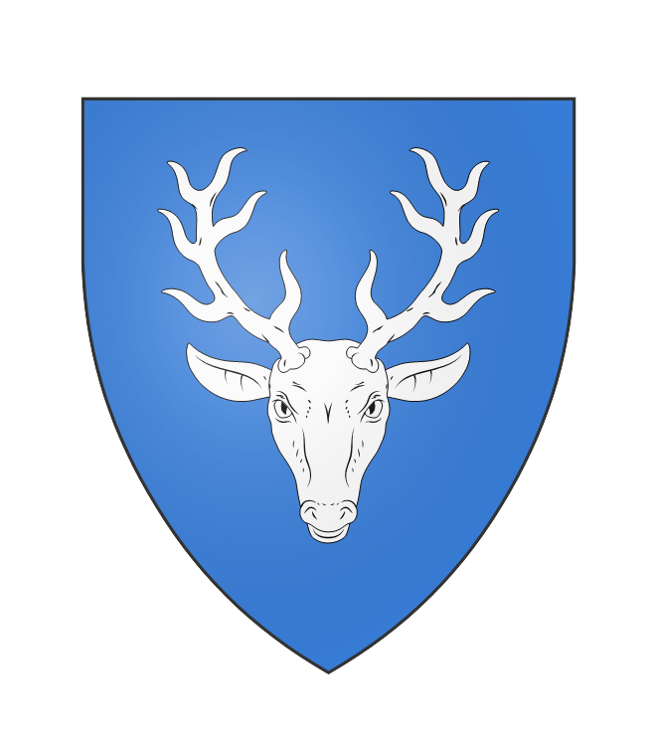 | Alba  The highland stag is a common cultural icon in Alba.
ARMS OF THE ROYAL HOUSES
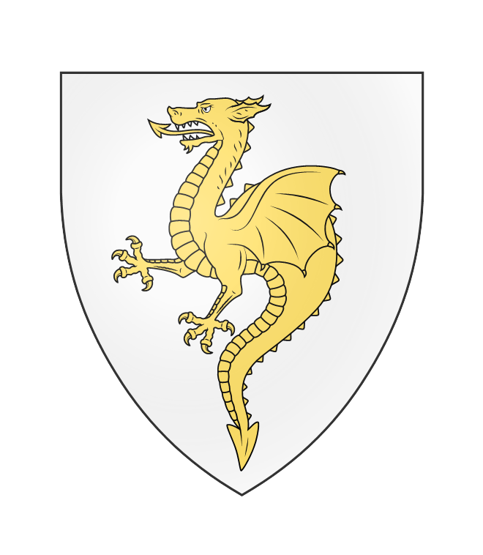 | House of Cauny  The golden wyvern is believed to be an honour bestowed upon Odo Caux’s great-grandfather Rolaf by the Lygos Emperor after his service in the Varansk Guard.
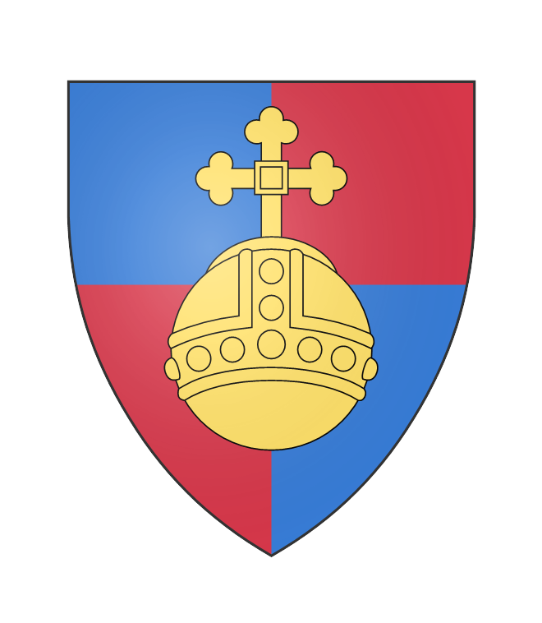 | House of Angevingia  The orb of Angevingia represents dominion across the globe, a reflection of Henry I’s ambition to rule domains across both Valois and Albany
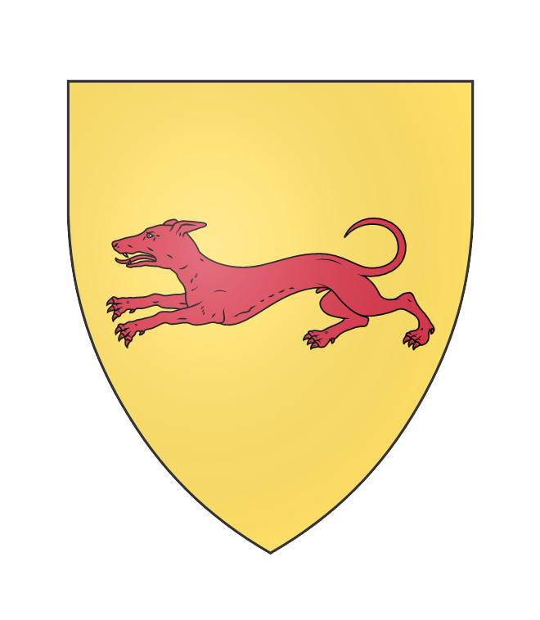 | House of Aberlune  The Red Hound of Aberlune is an ancient symbol of the city and is believed to be linked to a Brydon petty king who was famed for his hunting dogs.
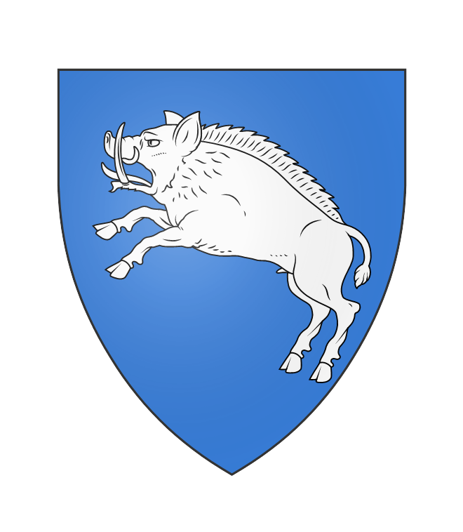 | House of Jorvale  The White Boar of Jorvale has two legends surrounding its origin. One posits it was an ancient Gallic totem for the area, another claims it was the personal arms of Erik Fairhair.
ARMS OF KINGDOMS
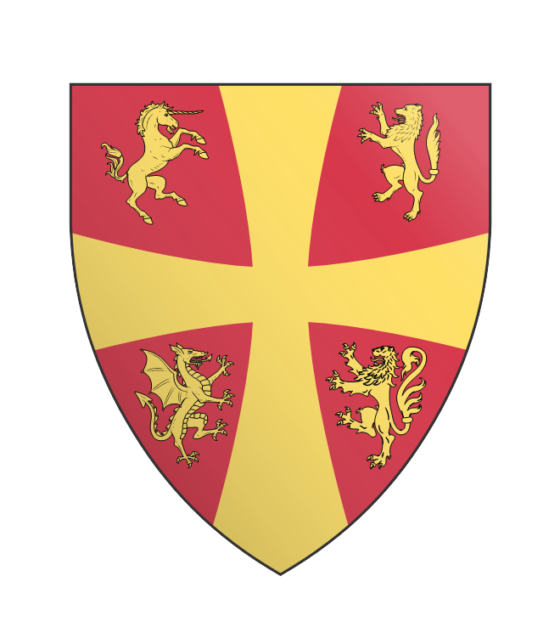 | Kingdom of Albany  The four beasts on the Kingdom’s arms represent the four Old Kingdoms
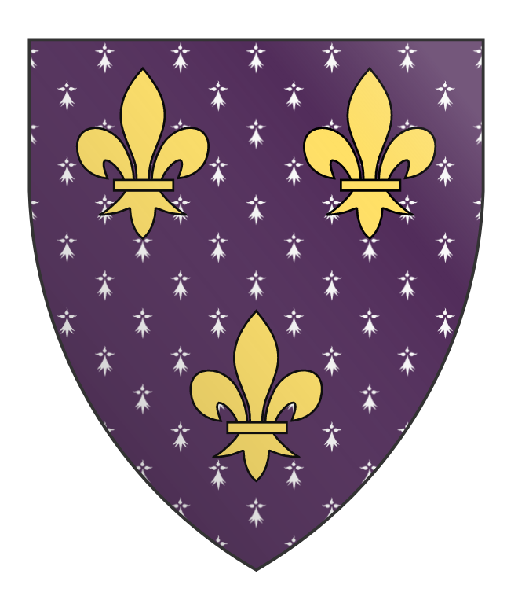 | Kingdom of Valois  The Fleur de Lys is an ancient Valois symbol of holy purity dating to the time of Luis I, the first king of the Valois.
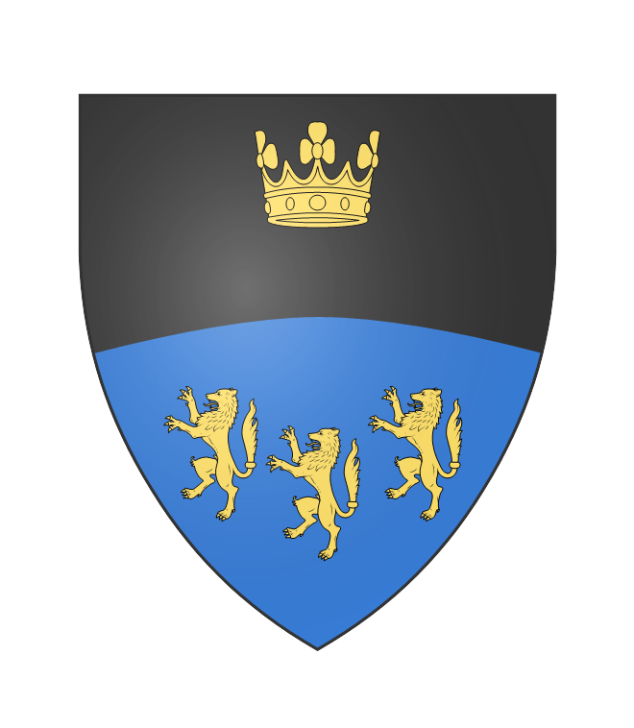 | Empire of Skadansk  The crown over the three wolves represents the King’s dominion over the three Skadansk nations of Skania, Svoriki and Noregi.
ARMS OF DUCHIES, COUNTIES, AND CITIES
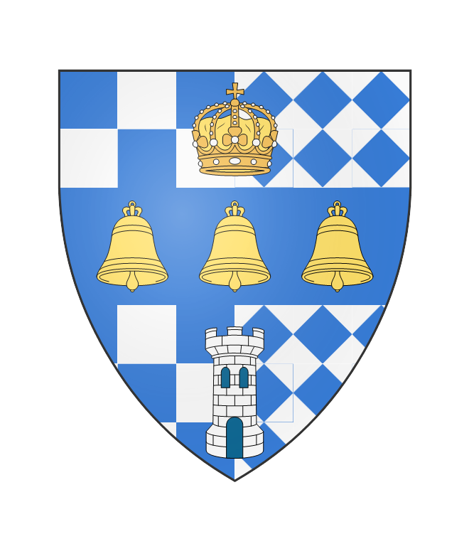 | City of Greatminster  The capital city’s arms display a crown, representing the King’s residence, three bells representing those found in Greatminster Cathedral, and the Tower of Greatminster. The underlying checkerboard is believed to be the arms of an ancient Saes king who founded the city.
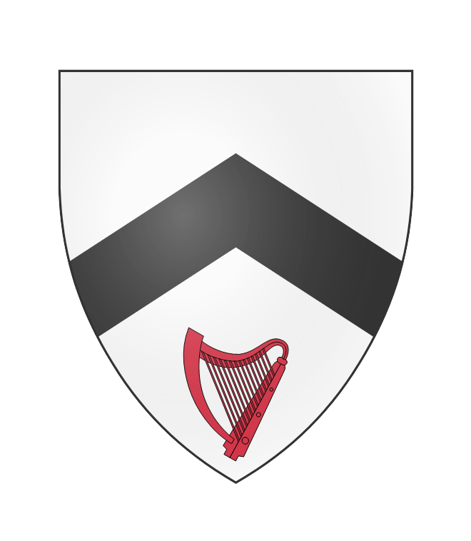 | Leirford  Skuli Red-Harp was the chief of the village of Leirford, south of Jorvale, and was pivotal to ensuring that Guillaume I’s victory over Erik Ironside at the battle of Leirford was costly. His eponymous harp was added to the arms by Ironside’s successors.
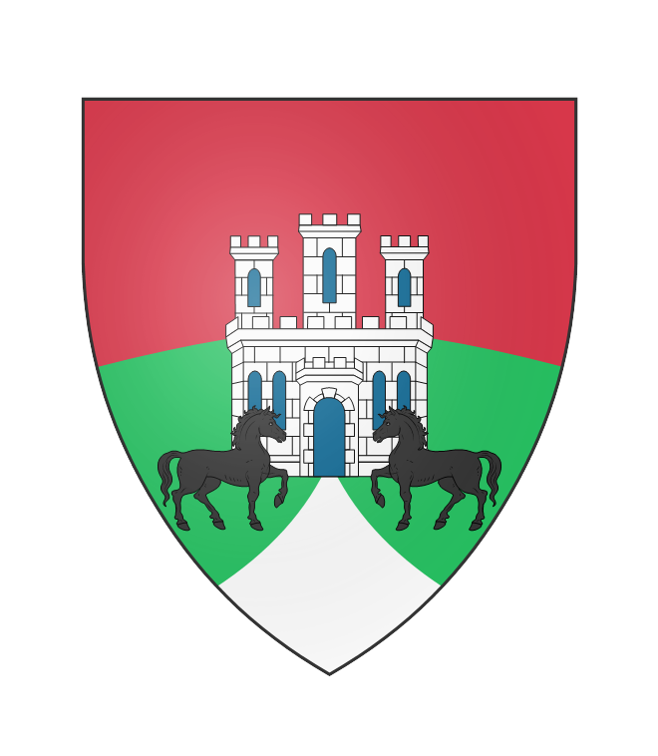 | City of Northome  The capital of Hameton’s arms depict Northome Palace, as well as the Black Steeds from the Royal Stables stationed within the city.
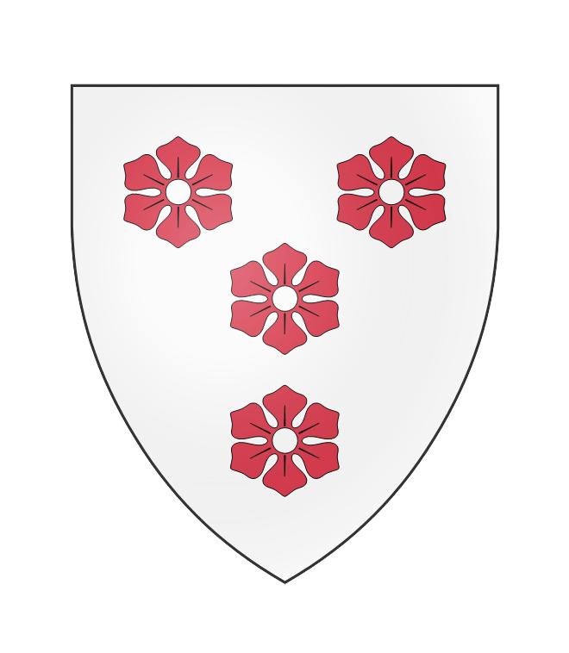 | City of Soarcester  The four Cinquefoils represent the four districts of the city: the Cathedral Quarter, the Commons, the Royal Quarter, and the Artistan’s Quarter.
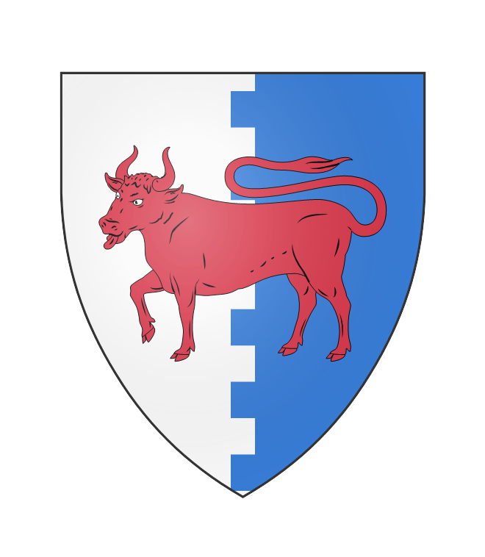 | County of Uxbridge  The Ox of crossing the River Graenta represents the cattle farms the area is famed for.
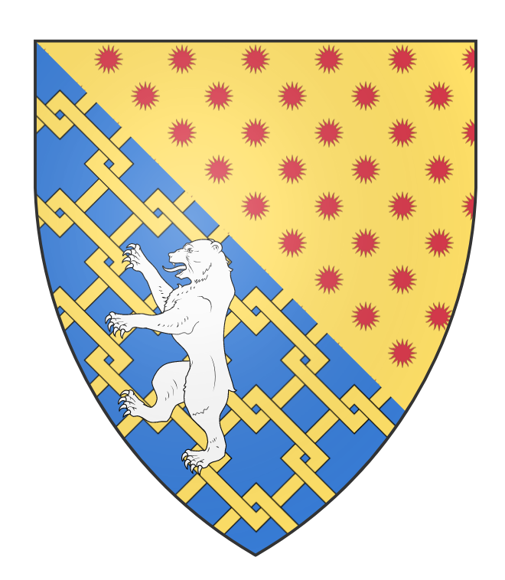 | Duchy of Waerick  The White Bear and gold chains are believed to be the old arms of the Saes Petty King of Waerick, and the red suns were the arms of the Norchois lord that took the holdings of Waerick. It is believed a marriage between the two families resulted in these arms.

